LAVA: A Lightweight Benchmarking Framework for Robust and Efficient Deepfake Voice Detection
Quoc Hung NGUYEN ^{*[0000-0002-6363-0160]},
Khac Anh Tuan PHAN ^{[0009-0006-5164-465X]}, Thanh Dat LAI ^{[0009-0002-3962-960X]}
Tan Khiem NGUYEN ^{[0009-0003-2085-6252]}, Thanh Dat TRUONG ^{[0009-0006-6562-3956]}
University of Economics Ho Chi Minh City (UEH), Ho Chi Minh City, Viet Nam
Corresponding author: hungngq@ueh.edu.vn
Abstract. LAVA compares heterogeneous deepfake-voice detectors under common integrity, P(FAKE), stress-diagnostic, and runtime contracts. Four locally trained Mel-sequence artifacts and externally pretrained RawNet2 and AASIST references were evaluated on a checksum-group-disjoint test set of 2,737 recordings. ShuffleNetV2 achieved F1 0.9824, ROC-AUC 0.9929, PR-AUC 0.9898, specificity 0.9848, and EER 1.46%. On one single-thread desktop CPU, MobileNetV3 had the lowest end-to-end latency (43.81 ms; RTF 0.0146). A fixed 100-recording diagnostic covered four AWGN levels, four codec round trips, and simulated replay; low-SNR noise was the main observed weakness. MobileNetV3 and ShuffleNetV2 were non-dominated under the evaluated objectives. The evidence supports offline deployment-oriented comparison, not full-test robustness, unseen-corpus, physical-replay, streaming, edge-device, or multi-seed claims.
Keywords: Deepfake voice detection, audio anti-spoofing, lightweight deep learning, robustness, computational efficiency, Pareto analysis.
- Introduction
Synthetic and converted speech pose risks to speaker verification and human decision-making. Surveys document rapid progress in deepfake voice detection [1], [2]. Shared resources such as ASVspoof and WaveFake support evaluation [3], [4]. Comparisons nevertheless remain difficult because studies differ in partitions, labels, duration, preprocessing, calibration, and runtime boundaries; byte-identical recordings across splits add an integrity risk.
LAVA compares heterogeneous deployed artifacts through one interface while preserving their Mel-sequence or raw-waveform pipelines. It standardizes integrity checks, P(FAKE) semantics, stress conditions, outputs, and timing. Four artifacts were trained locally; RawNet2 and AASIST are external references. Clean evaluation uses the full test set, stress diagnostics use a fixed subset, and timing uses one desktop CPU, so the evidence does not establish general robustness, streaming, or edge-device operation. The study addresses:
- RQ1: How do deployed artifacts compare on clean AUC and EER, and how should threshold-dependent metrics be interpreted under heterogeneous training and calibration?
- RQ2: How does absolute performance change under the executed noise, codec, and simulated-replay conditions on the fixed diagnostic subset?
- RQ3: Which artifacts are non-dominated across diagnostic-subset EER, mean stressed F1, and end-to-end RTF?
The study makes three evidence-backed contributions:
• A checksum-group-disjoint, artifact-traceable clean evaluation contract centered on ROC-AUC/EER, calibrated score semantics, and explicit provenance.
• Matched fixed-subset diagnostics for multiple noise levels, codec settings, and simulated replay, with aggregate failure-pattern analysis.
• Single-thread desktop-CPU timing and exploratory three-objective Pareto analysis for scenario-specific artifact selection.
- Related Work
  - Deepfake Voice Detection and Benchmark Protocols
ASVspoof 2019 separates logical-access synthesis and conversion from replay-oriented physical access [3]. ASVspoof 2021 adds channel, compression, and real-environment replay variation [5]. WaveFake covers multiple generators and two languages [4]. RawNet2 and SincNet represent raw-waveform modeling [6], [7]. AASIST and wav2vec 2.0 broaden graph and self-supervised representations [8], [9]. Scores remain tied to each dataset, attack partition, preprocessing, and decision protocol.
  - Robustness Replay and Unseen Data Generalization
Robustness and generalization concern different shifts. ASVspoof tasks cover simulated or real-environment replay and channel variation [3], [5]. A wav2vec 2.0 system addresses unmatched codec, attack, and source-domain variation [9]. Cross-source studies test generalization beyond one partition [10], [11]. Other work examines attack-agnostic data and the nature of domain shift [12], [13]. Cross-domain corpora extend this evidence [14]. Recent studies examine non-semantic representations and physical speaker-microphone replay [22], [23]. Multilingual cross-domain evaluation is also emerging [24]. These protocols are not interchangeable.
  - Computational Efficiency and Deployment Oriented Evaluation
Deployment evidence requires a common workload and timing boundary. MobileNet variants report efficiency for vision workloads [15], [17]. ShuffleNet variants do likewise [16], [18]. MnasNet and EfficientNet target mobile or compound scaling [19], [20]. These are not complete audio-pipeline measurements. Anti-spoofing studies mainly emphasize EER or t-DCF [6], [8]. Wav2vec-based work also focuses on detection rather than matched end-to-end timing [9]. Model size alone is not a deployment proxy.
The surveyed studies assess clean discrimination, robustness or generalization, and efficiency under different protocols, making deployment-oriented comparison across heterogeneous artifacts difficult. LAVA addresses this comparability gap with one artifact-traceable offline contract; it does not claim unseen-corpus generalization, physical-replay robustness, streaming, or edge-device validation.
- Methodology
  - LAVA Framework and Experimental Protocol
LAVA separates canonical data and integrity, registered detectors, conditions, measurements, and analyses. The registry records each artifact's input, duration, threshold, and provenance; adapters preserve native computation while exposing common scores and resource measures. Figure 1 summarizes the six-detector contract, and Figure 2 shows the integrity-controlled data flow.

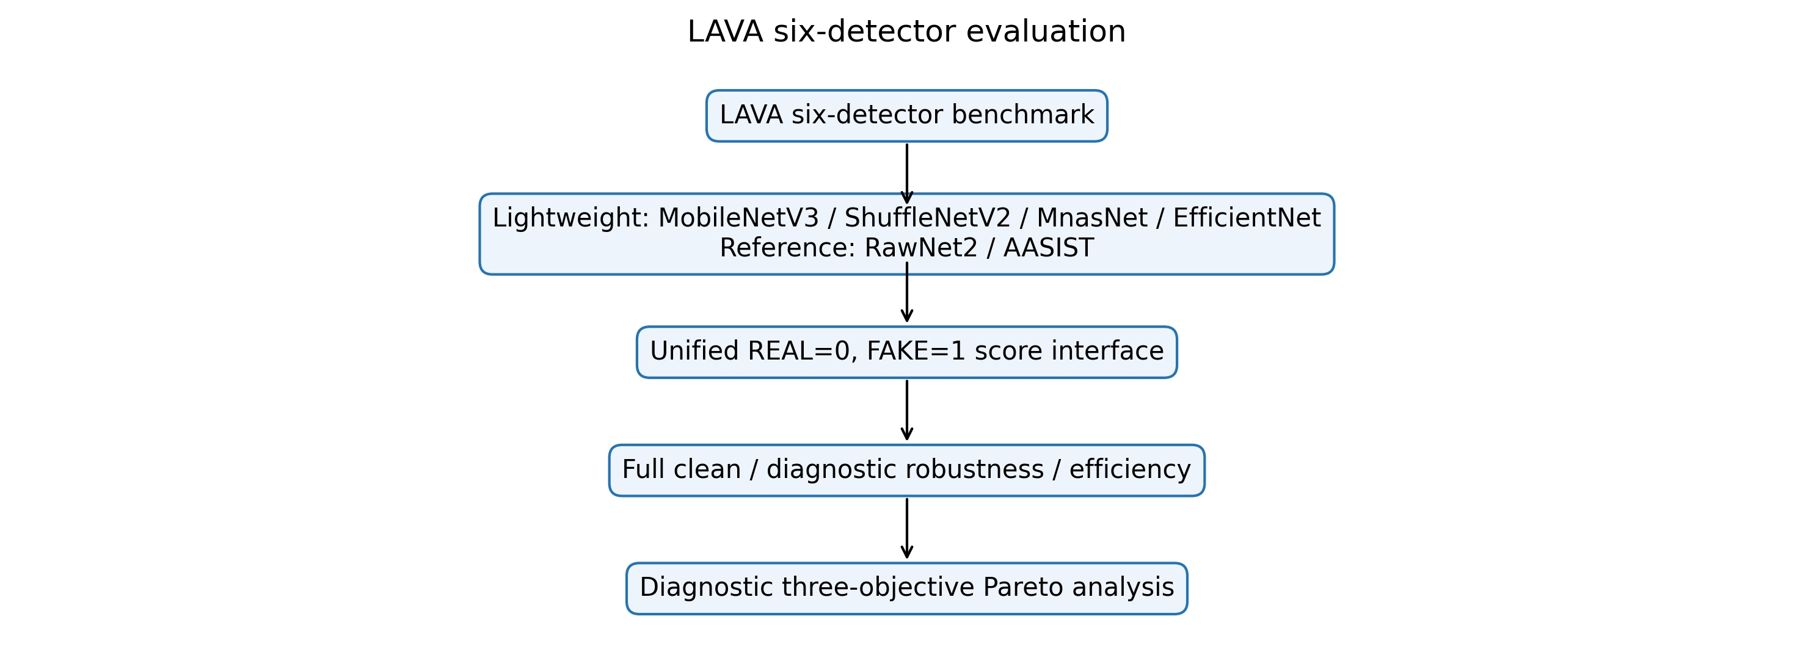
Fig. 1. Six detectors under the unified LAVA evaluation contract.
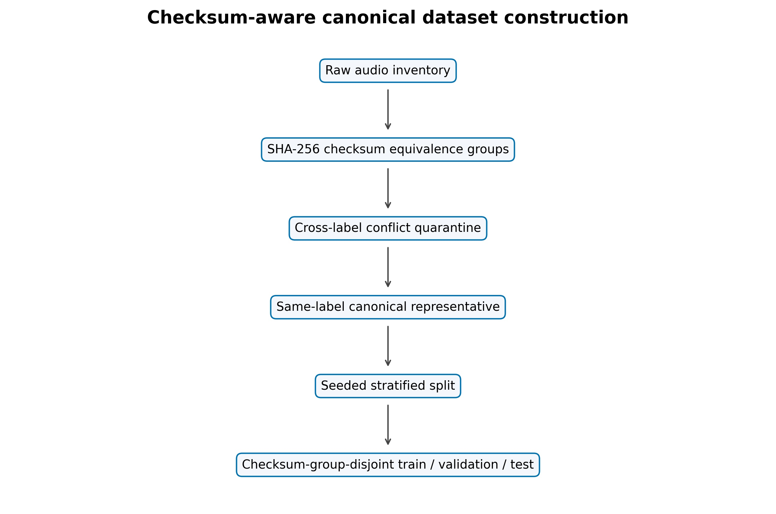
Fig. 2. SHA-256 conflict quarantine, canonicalization, and checksum-group-disjoint splitting.

  - Dataset Integrity and Canonical Split
The repository contains an internally assembled collection, but its manifest does not retain source-dataset, speaker, source, generator, parent-recording, or dataset identifiers; those provenance fields are therefore reported as UNKNOWN rather than inferred. LAVA scanned 18,722 recordings (10,550 REAL; 8,172 FAKE). Files were grouped by exact byte-level SHA-256. Every member of a checksum group carrying both labels was quarantined: 14 such groups contained the 30 cross-label files. Within each remaining same-label group, the lexicographically first path was retained as the canonical representative and the other byte-identical copies were excluded. The resulting 18,232 recordings (10,493 REAL; 7,739 FAKE) were split with seed 42 into 12,762/2,733/2,737 train/validation/test files (Table 1). The supported property is checksum-group disjointness, not speaker-, source-, generator-, or corpus-disjointness. For h(x) = SHA256(x) and split group sets Gs,
$$x_{i}∼x_{j}⇔h\left(x_{i}\right)=h\left(x_{j}\right), G_{tr}∩G_{va}=G_{tr}∩G_{te}=G_{va}∩G_{te}=∅.$$
Table 1. Canonical manifest and split inventory
Inventory | Count | Split | Count
Scanned / retained | 18,722 / 18,232 | Train | 12,762
Retained REAL / FAKE | 10,493 / 7,739 | Validation | 2,733
Duplicate groups / redundant | 435 / 476 | Test | 2,737
Cross-label groups / files | 14 / 30 | Split property | checksum-group-disjoint

  - Standardized Audio Preprocessing
Lightweight inputs are decoded, channel-averaged, polyphase-resampled to 22,050 Hz, and padded/truncated to 3.0 s. Six chronological 0.5-s segments use a Hann STFT (N = 2048, hop 512), 128 HTK-style Mel filters spanning 20–8,000 Hz, relative dB mapping clipped to 80 dB, [0, 255] scaling, bilinear 224 × 224 resizing, and RGB replication [21]. For segment t
  - Evaluated Detector Architectures
The lightweight family uses TimeDistributed MobileNetV3Small, ShuffleNetV2-1.0x, MnasNet-A1-1.0, or EfficientNet-B0 segment encoders. Each encoder produces six embeddings, an LSTM with 128 units aggregates them, and a 64-unit ReLU layer plus dropout 0.4 feeds a sigmoid. RawNet2 instead uses a Sinc-style waveform front end, residual temporal blocks, attention, a GRU, and a two-class head [6], [7]. AASIST combines a raw-waveform front end with spectral-temporal graph attention, heterogeneous graph interaction, pooling, and two-class readout [8]. Figure 3 summarizes architecture and provenance:
  - Training Artifact Provenance and Score Semantics
MobileNet and EfficientNet use ImageNet initialization; EfficientNet-B0 is the available warm-up checkpoint, not a completed fine-tuning result. MnasNet and ShuffleNet were trained from scratch, while RawNet2 and AASIST are external references (Table 1).

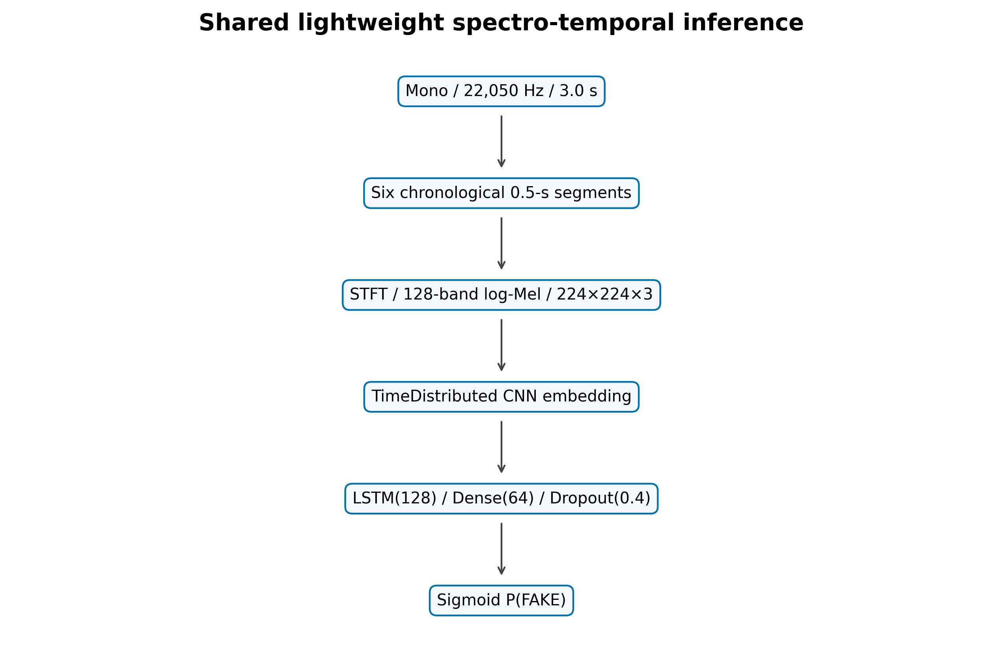
(a) Mel-sequence temporal path

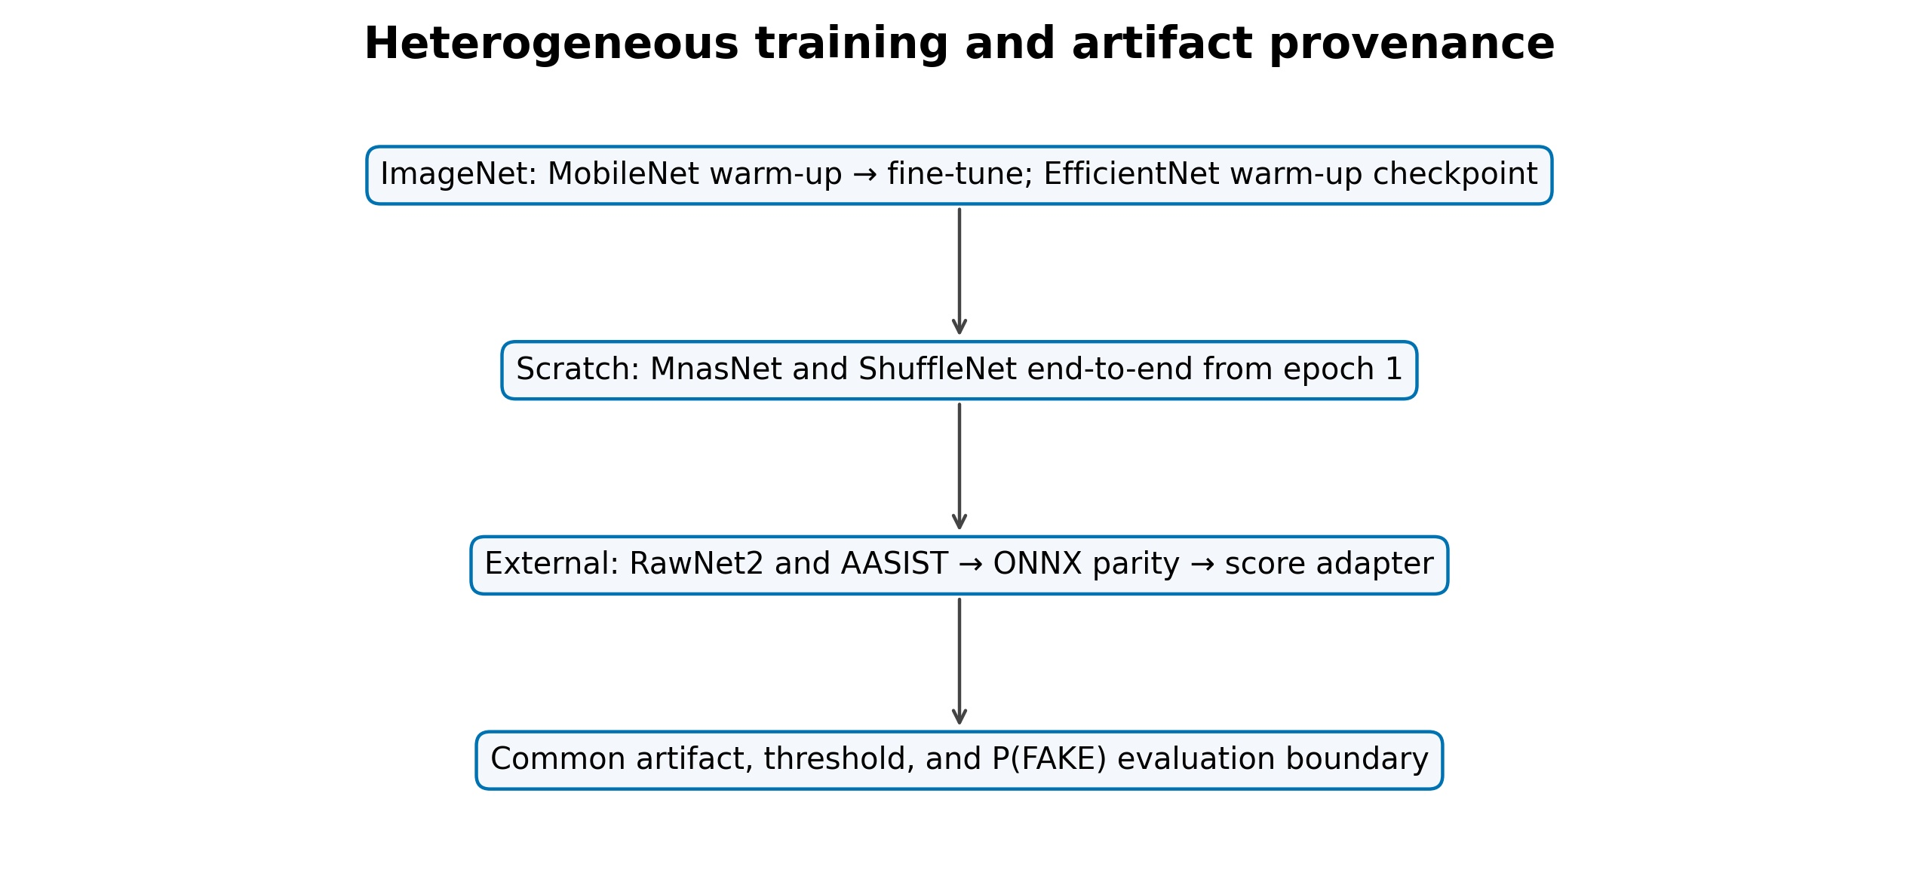
(b) Artifact provenance
Fig. 3. Lightweight architecture and artifact provenance; evaluation is shared, training is not.
Table 2. Detector specification, provenance, and deployed threshold
Detector | Framework/input | Architecture/params | Initialization/provenance | Training/artifact policy | Threshold
MobileNetV3-LSTM [15] | TF/Keras; 6×Mel RGB, 3.0 s | MobileNetV3Small → LSTM(128); 1.308M | ImageNet; local | 50×10−4 warm-up; 50×10−5 last-20-layer fine-tune; BN frozen | .82; val-F1
ShuffleNetV2-LSTM [16] | TF/Keras; 6×Mel RGB, 3.0 s | ShuffleNetV2-1.0x → LSTM(128); 1.868M | scratch; local | Adam 3×10−4; end-to-end; 28 epochs, best 16 | .12; val-F1
MnasNet-A1-LSTM [19] | TF/Keras; 6×Mel RGB, 3.0 s | MnasNet-A1 → LSTM(128); 3.369M | scratch; local | Adam 10−4; clip 1; WD 10−5; LS .1; 39 epochs, best 27 | .90; val-F1
EffNet-B0 warm-up [20] | TF/Keras; 6×Mel RGB, 3.0 s | EfficientNet-B0 → LSTM(128); 4.779M | ImageNet; local | available warm-up checkpoint: epoch 47 at 10−4; fine-tune incomplete | .90; val-F1
RawNet2 [6] | PyTorch→ONNX; waveform, 4.04 s | Sinc + residual blocks + attention + GRU; 17.621M | external reference | no local training; exported checkpoint | .50; default
AASIST [8] | PyTorch→ONNX; waveform, 4.04 s | spectro-temporal graph attention; 0.298M | external reference | no local training; exported checkpoint | .50; default
All local runs used batch size 16, seed 42, validation-loss checkpointing, early stopping, and ReduceLROnPlateau; Table 2 gives artifact-specific initialization, learning rates, regularization, stopping outcomes, and calibration. RawNet2 and AASIST were not locally trained; their external checkpoints were loaded in PyTorch and exported to ONNX.
LAVA fixes REAL=0 and FAKE=1; every adapter returns p = P(FAKE) and applies the detector threshold listed in Table 2.
$$\overset{ˆ}{y}=1\left[p≥τ\right], τ^{*}=\arg{\max_{τ}{F}}1_{val}\left(τ\right).$$
The four lightweight thresholds in Table 2 are validation-only. The external reference artifacts use the uncalibrated default threshold of 0.5. Labels do not influence threshold selection or weighting, and scores are not interpreted as calibrated real-world probabilities.
  - Clean and Diagnostic Stress Evaluation
Clean evaluation uses all 2,737 test recordings (1,575 REAL, 1,162 FAKE). Accuracy, precision, recall, F1, macro-F1, ROC-AUC from raw scores, and linearly interpolated EER are reported. With FAKE positive,
Diagnostic stress evaluation uses a fixed 100-recording subset (58 REAL, 42 FAKE; seed 42), and every artifact uses the same recordings. Four seeded AWGN levels (20, 10, 5, 0 dB) use sample-identity-derived seeds. FFmpeg round trips cover MP3 128/64 kb/s, Opus 64 kb/s, and AAC 96 kb/s. Simulated replay applies taps at 0/17/43/89 ms with gains 1/.45/.25/.12, normalization by 1.82, and a causal fourth-order 100-3,800-Hz band-pass; it is not physical replay. For nine conditions,
$$Δ{F1}_{k}={F1}_{clean}-{F1}_{k}, {\overline{F1}}_{stress}=\frac{1}{9}\sum_{k=1}^{9}{{F1}_{k}}.$$
Negative degradation denotes improvement relative to a low diagnostic-subset baseline and is not evidence of general robustness. Full-test stress evaluation was not run; physical replay and unseen-corpus evaluations are not available.
  - Computational Efficiency Evaluation
Each artifact runs float32, batch one, one backend thread, and no accelerator in an isolated process. Ten warm-ups precede 50 timed runs. Measures include model-only and end-to-end latency, P95, load time, throughput, and whole-process RSS. The host is an AMD Ryzen 9 8940HX with 15.28 GiB usable RAM on 64-bit Windows 11 Pro build 26200; TensorFlow 2.15 and ONNX Runtime 1.17.3 execute the local and external artifacts, respectively. For N clips,
An RTF below one indicates faster-than-duration offline processing on this host; it does not establish causal streaming or edge-device deployment.
Uncertainty uses a stratified test-set percentile bootstrap (1,000 iterations; seed 42) for F1, ROC-AUC, and EER (Table 3). Paired correctness uses exact McNemar tests with Holm correction; this fixed-test evidence does not replace repeated training over independent seeds.
The exploratory Pareto analysis minimizes diagnostic-subset EER and end-to-end RTF while maximizing mean F1 across the nine executed stress conditions. After negating mean stressed F1, A dominates B when every objective is no worse and at least one is better:
$$g(m)=({EER}_{diag}(m),-{\overline{F1}}_{stress}(m),RTF(m)).$$
$$g_{i}(A)≤g_{i}(B) ∀i, and ∃j:g_{j}(A)<g_{j}(B).$$
Table 3. Clean performance on all 2,737 canonical test recordings. Specificity, precision, recall, F1, and macro-F1 use each artifact's threshold; ROC-AUC, PR-AUC, and EER use raw P(FAKE) scores.
Artifact | Precision | Recall | Specificity | F1 [95% CI] | Macro-F1 | ROC-AUC [95% CI] | PR-AUC | EER [95% CI]
MobileNetV3 | .9741 | .9707 | .9810 | .9724 [0.9654,0.9788] | .9761 | .9911 [0.9871,0.9947] | .9864 | .0250 [0.0178,0.0311]
ShuffleNetV2 | .9795 | .9854 | .9848 | .9824 [0.9768,0.9875] | .9847 | .9929 [0.9894,0.9960] | .9898 | .0146 [0.0103,0.0207]
MnasNet-A1 | .9599 | .9690 | .9702 | .9645 [0.9573,0.9717] | .9690 | .9886 [0.9842,0.9923] | .9823 | .0310 [0.0250,0.0379]
EffNet-B0 warm-up | .9724 | .9406 | .9803 | .9563 [0.9477,0.9651] | .9624 | .9877 [0.9833,0.9917] | .9802 | .0400 [0.0311,0.0482]
RawNet2 ext. | .4380 | .6807 | .3556 | .5330 [0.5150,0.5489] | .4900 | .5178 [0.4944,0.5395] | .4161 | .4813 [0.4616,0.5016]
AASIST ext. | .4758 | .5585 | .5460 | .5139 [0.4928,0.5349] | .5487 | .5597 [0.5377,0.5815] | .4269 | .4463 [0.4279,0.4660]

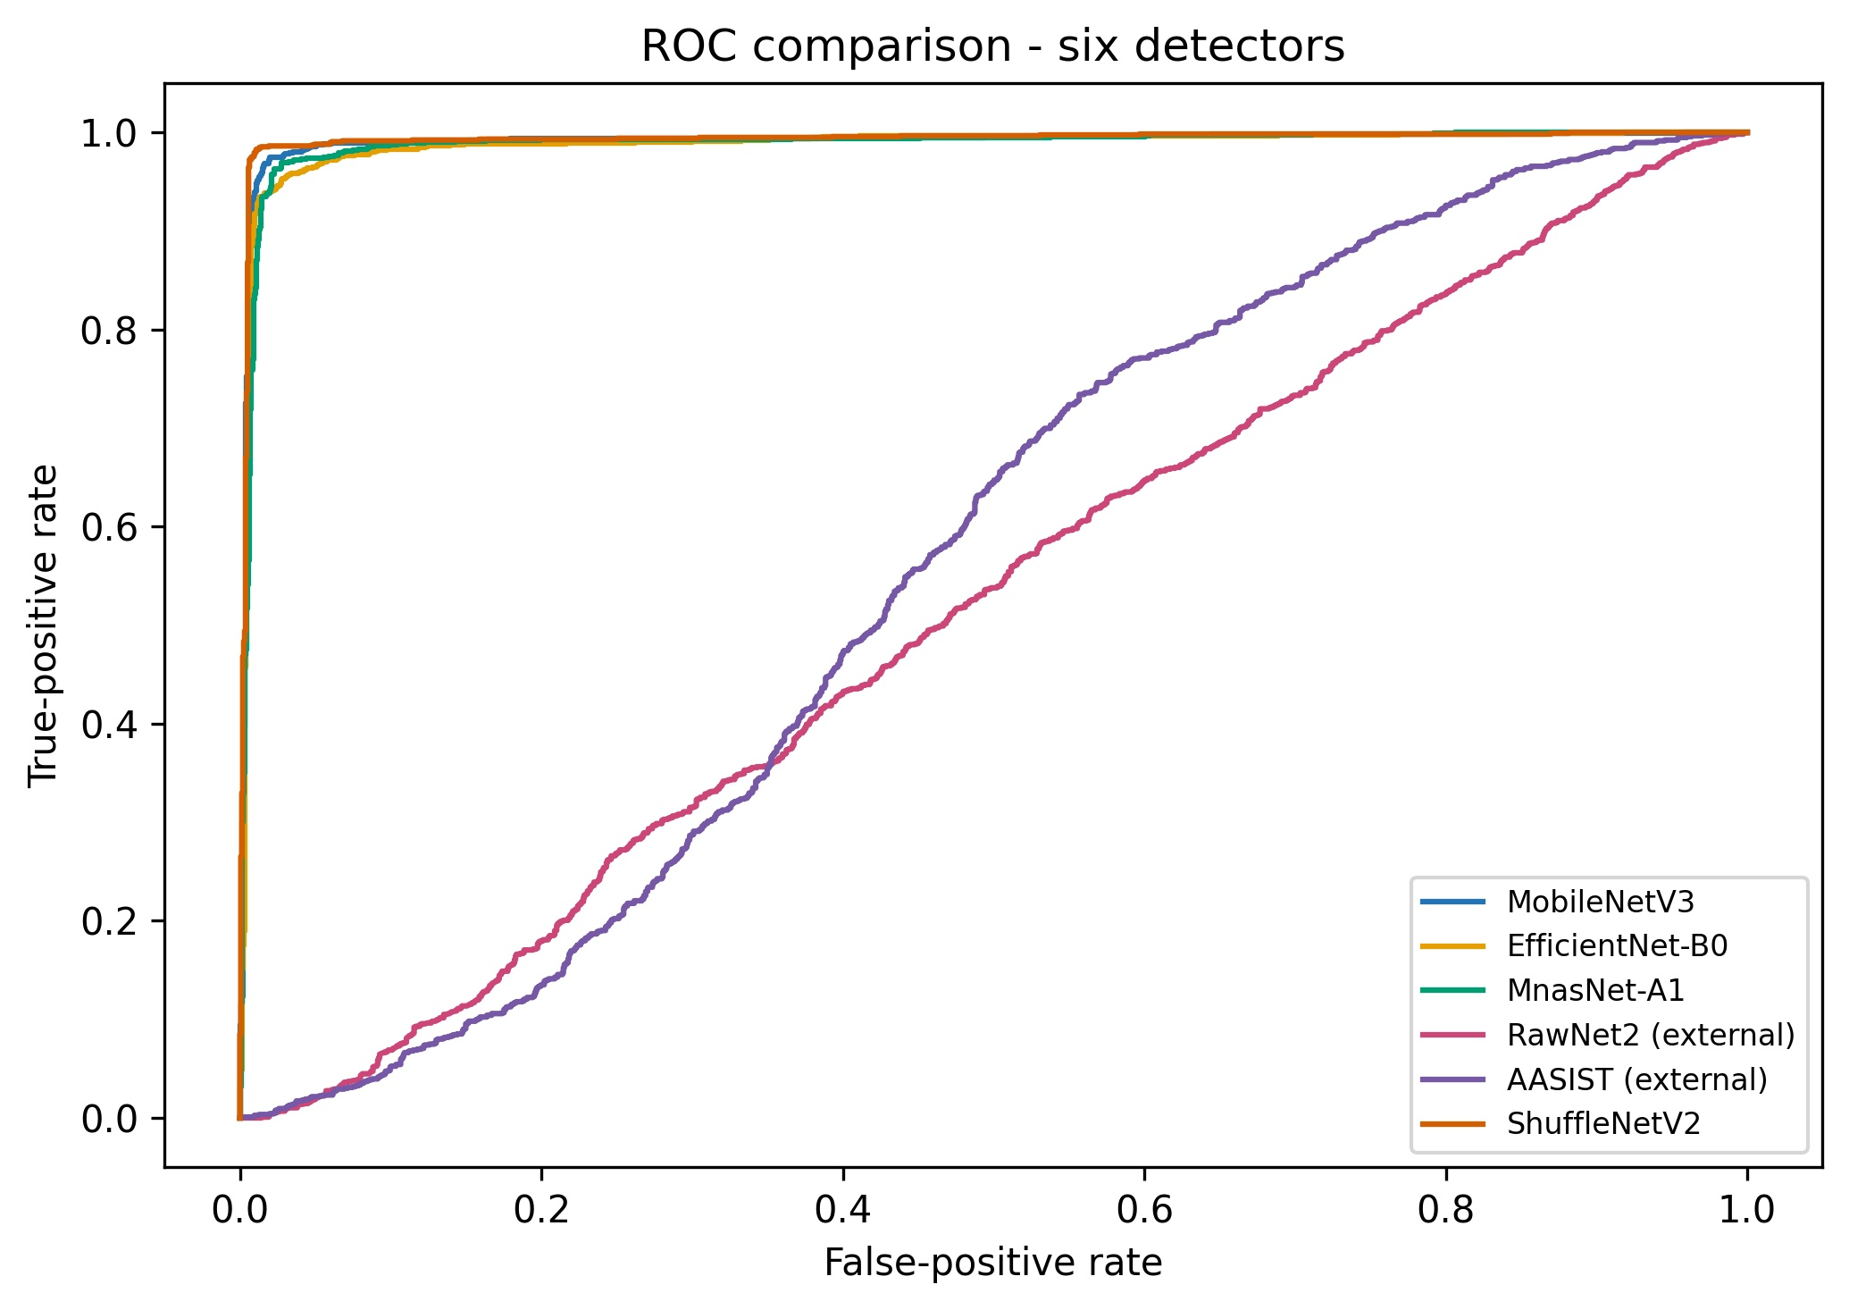
- ROC
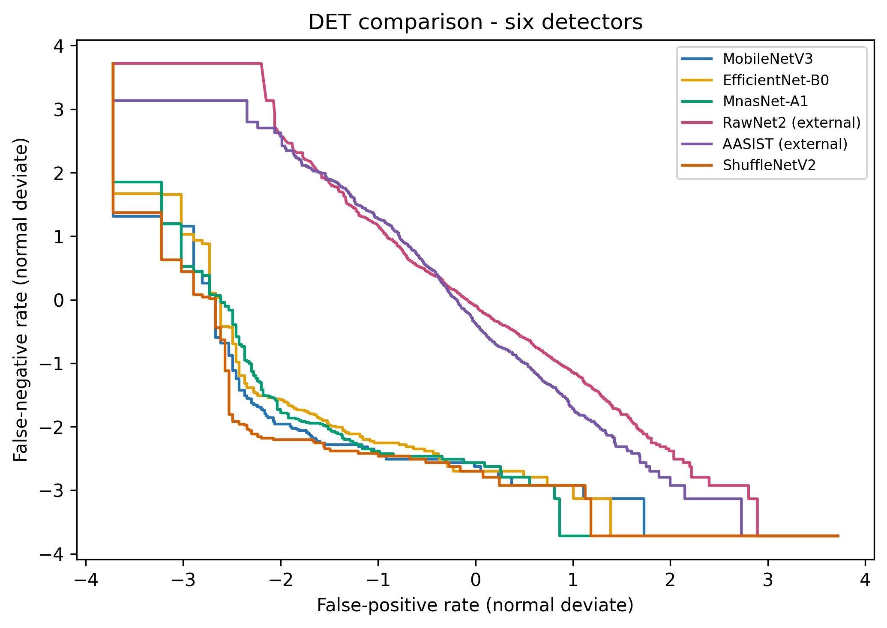
- DET/EER
Fig. 4. Full-test ROC and DET comparisons for six detector artifacts.
- Results and Discussion
  - RQ1 Clean Detection Performance
All artifacts passed load, score, hash, and adapter checks. ShuffleNetV2 had the highest ROC-AUC (0.9929), PR-AUC (0.9898), specificity (0.9848), and lowest EER (0.0146), followed by MobileNetV3, MnasNet-A1, and the available EfficientNet-B0 warm-up checkpoint (Table 3). Table 3 reports the corresponding bootstrap intervals.
This is not a controlled architecture study. Training data, initialization, duration, representation, loaders, and calibration differ across artifacts; the results neither rank the RawNet2 or AASIST architectures nor estimate retrained performance. On fixed test predictions, ShuffleNetV2 differed from MobileNetV3 after Holm correction (adjusted p = 0.0096), and both differed strongly from the two external checkpoints; this is paired test-set evidence, not multi-seed training significance.
  - RQ2 Diagnostic Performance under Executed Distortions
On the fixed 100-recording diagnostic subset, AWGN caused the largest observed losses for the four high-performing lightweight artifacts. Mean noise ΔF1 ranged from 0.3555 for ShuffleNetV2 to 0.8053 for the available EfficientNet-B0 warm-up checkpoint and rose sharply at 5 and 0 dB. Table 4 and Figure 5 report the condition-level patterns.
Table 4. Fixed 100-recording diagnostic stress results. ΔF1 is clean minus stressed perfor-mance; replay is simulated.
Artifact | Clean F1 | Diagnostic EER | Noise ΔF1 | Codec ΔF1 | Sim. replay ΔF1 | Mean stressed F1
MobileNetV3 | .9756 | .0476 | .6722 | .0095 | .0620 | .6657
ShuffleNetV2 | .9756 | .0476 | .3555 | .0032 | .0256 | .8133
MnasNet-A1 | .9756 | .0476 | .6119 | .0233 | .1489 | .6767
EffNet-B0 warm-up | .9630 | .0476 | .8053 | .0000 | .0641 | .5980
RawNet2 ext. | .5660 | .4138 | .5077 | −.0007 | −.0109 | .3419
AASIST ext. | .5060 | .3810 | −.0660 | −.0074 | −.0682 | .5462

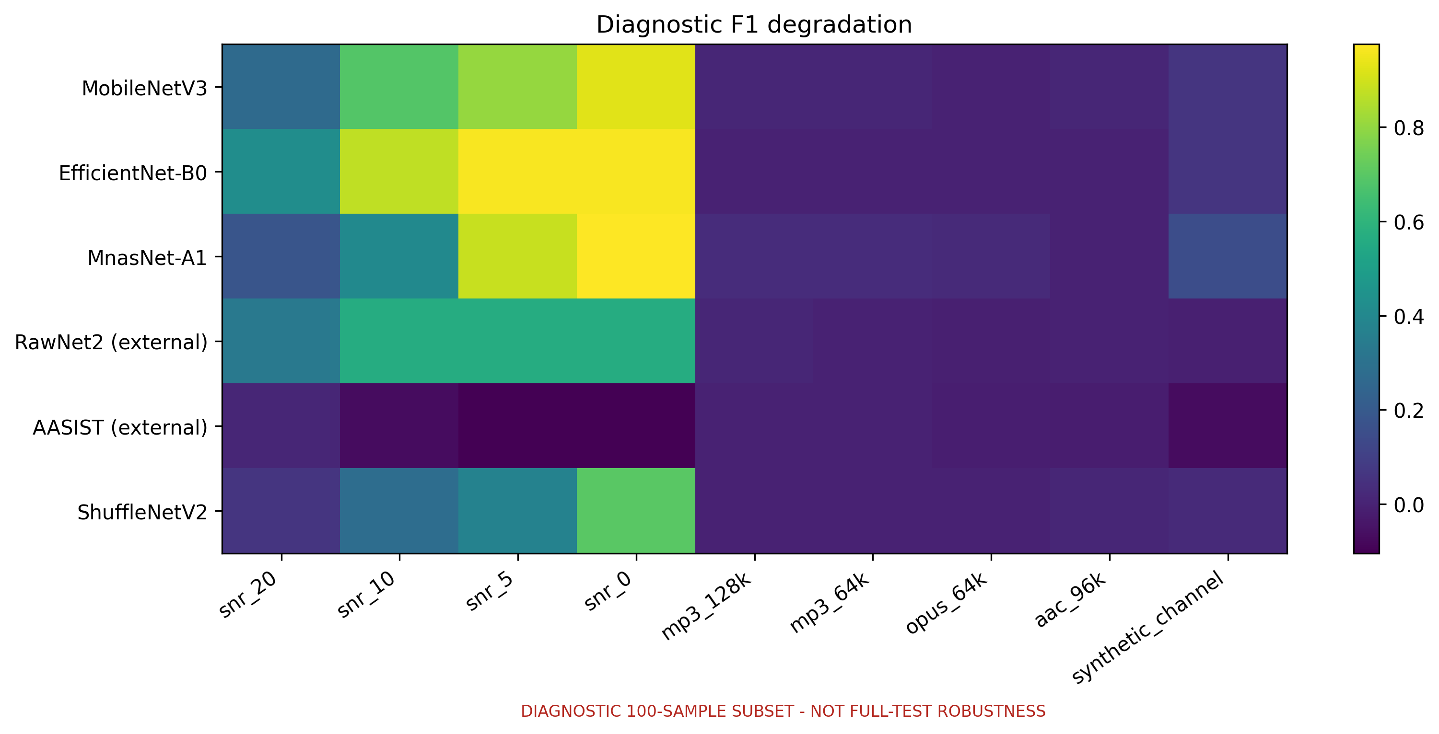(a) Nine-condition degradation
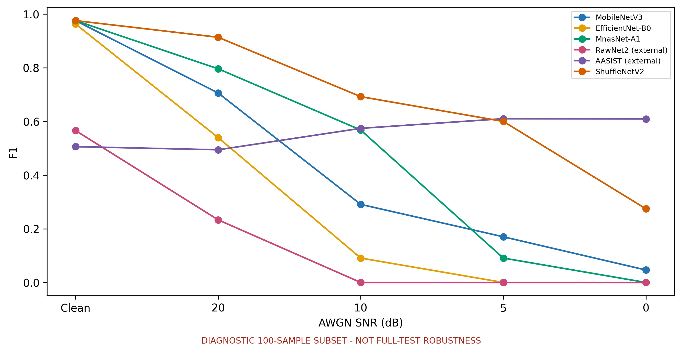 (b) AWGN F1 trajectory
Fig. 5. Fixed-subset degradation and AWGN F1; replay is simulated.
On the fixed subset, codec effects were small for the lightweight artifacts (mean ΔF1: 0.0000-0.0233). Under simulated replay, ShuffleNetV2 retained F1 = 0.9500 (ΔF1 = 0.0256), versus ΔF1 values of 0.0620, 0.0641, and 0.1489 for MobileNetV3, the EfficientNet-B0 warm-up checkpoint, and MnasNet-A1. Negative external-artifact deltas reflect score redistribution around weak baselines, not general robustness.
Because paired clean/stressed scores were not retained, prediction flips cannot be identified; the reported condition-level trends are aggregate failure patterns, not per-recording error analysis.
  - Computational Efficiency
On the single-thread desktop CPU (Table 5), MobileNetV3 had the lowest end-to-end latency and RTF; ShuffleNetV2 ranked second among local artifacts. AASIST combined the smallest file with the largest latency, whereas RawNet2 combined the most parameters with moderate latency. Size and parameter count did not predict runtime; RSS is whole-process memory.
Table 5. Float32 batch-one desktop-CPU efficiency on AMD Ryzen 9 8940HX (10 warm-ups, 50 timed runs). RSS is whole-process memory.
Artifact | Params | Size (MiB) | RSS (MiB) | Model ms | E2E ms | P95 ms | clips/s | RTF
MobileNetV3 | 1.31M | 5.64 | 554.6 | 30.07 | 43.81 | 52.12 | 22.83 | .0146
ShuffleNetV2 | 1.87M | 7.74 | 501.8 | 48.05 | 62.52 | 75.37 | 15.99 | .0208
MnasNet-A1 | 3.37M | 13.43 | 566.0 | 95.25 | 117.00 | 138.96 | 8.55 | .0390
EffNet-B0 warm-up | 4.78M | 18.96 | 651.2 | 168.36 | 175.85 | 196.11 | 5.69 | .0586
RawNet2 ext. | 17.62M | 67.65 | 249.5 | 95.10 | 96.54 | 102.62 | 10.36 | .0239
AASIST ext. | 0.30M | 1.61 | 442.5 | 359.61 | 362.91 | 398.45 | 2.76 | .0899
  - RQ3 Corrected Pareto Trade-offs
Figure 6 identifies MobileNetV3 and ShuffleNetV2 as non-dominated under the evaluated objectives. MobileNetV3 has the lowest RTF (0.0146); ShuffleNetV2 has the highest mean stressed F1 (0.8133) at RTF 0.0208 and dominates the other four artifacts under these objectives. The frontier is exploratory, not a generally optimal ranking, because it uses 100 stress recordings and one desktop host.
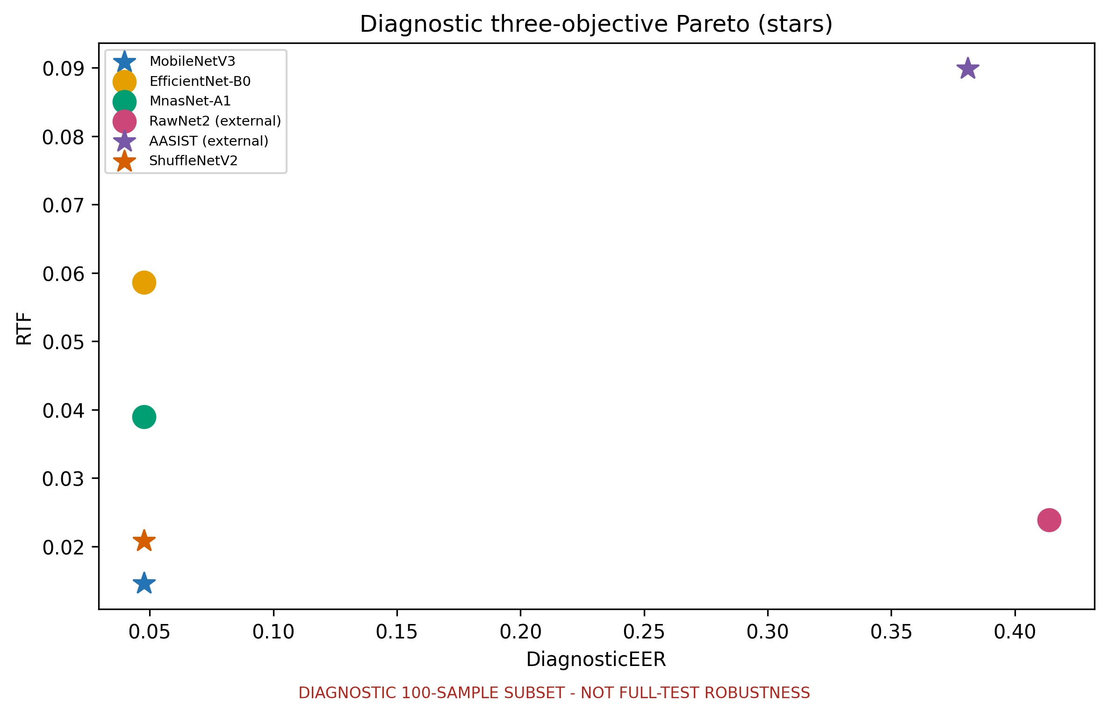
Fig. 6. Exploratory Pareto space under the evaluated objectives; stars mark non-dominated artifacts.
- Practical and Societal Implications
LAVA can support transparent artifact selection for defensive voice-authentication and media-verification screening, while retaining human review for consequential decisions. Its offline diagnostic evidence is not a guarantee of field security, demographic fairness, or edge-device readiness.
- Limitations
Evidence is limited by heterogeneous training and calibration, a fixed 100-recording diagnostic subset, simulated rather than physical replay, and one desktop CPU. The dataset cannot establish speaker, source, generator, parent-recording, or cross-dataset independence. No unseen-corpus, edge-device, streaming, or multi-seed evaluation was conducted; RSS is whole-process memory, EfficientNet-B0 is an available warm-up checkpoint, and paired scores for sample-level prediction-flip analysis are unavailable.
- Conclusion
Recommendations remain artifact-, objective-, and platform-specific. Under the evaluated objectives, ShuffleNetV2 is the stronger predictive-performance candidate: it achieved the highest clean AUC, lowest clean EER, highest mean stressed F1, and remained non-dominated at RTF 0.0208. MobileNetV3 is the lower-latency candidate on the measured host. These findings do not identify a universally optimal model or rank architectures independently of their available artifacts.
LAVA compares six heterogeneous voice anti-spoofing artifacts under traceable contracts. MobileNetV3 and ShuffleNetV2 are non-dominated under the evaluated objectives, while low-SNR noise is the main weakness on the fixed diagnostic subset. Future work should add paired full-stress scores, multi-seed training, unseen corpora, physical replay, causal streaming, and representative edge hardware.

Acknowledgement
This research was supported by the University of Economics Ho Chi Minh City (UEH), Vietnam.

References
[1] J. Yi et al., ‘Audio Deepfake Detection: A Survey,’ arXiv:2308.14970, 2023. doi:10.48550/arXiv.2308.14970.  [2] M. Li, Y. Ahmadiadli, and X.-P. Zhang, ‘A Survey on Speech Deepfake Detection,’ ACM Computing Surveys, vol. 57, no. 7, pp. 1-38, 2025. doi:10.1145/3711898.  [3] M. Todisco et al., ‘ASVspoof 2019: Future Horizons in Spoofed and Fake Audio Detection,’ Proc. Interspeech, pp. 1008-1012, 2019. doi:10.21437/Interspeech.2019-2249.  [4] J. Frank and L. Schönherr, ‘WaveFake: A Data Set to Facilitate Audio Deepfake Detection,’ NeurIPS Datasets and Benchmarks, 2021, arXiv:2111.02813. doi:10.48550/arXiv.2111.02813.  [5] J. Yamagishi et al., ‘ASVspoof 2021: Accelerating Progress in Spoofed and Deepfake Speech Detection,’ Proc. ASVspoof 2021 Workshop, pp. 47-54, 2021. doi:10.21437/ASVSPOOF.2021-8.  [6] H. Tak et al., ‘End-to-End Anti-Spoofing with RawNet2,’ Proc. ICASSP, pp. 6369-6373, 2021. doi:10.1109/ICASSP39728.2021.9414234.  [7] M. Ravanelli and Y. Bengio, ‘Speaker Recognition from Raw Waveform with SincNet,’ Proc. IEEE SLT Workshop, pp. 1021-1028, 2018. doi:10.1109/SLT.2018.8639585.  [8] J.-w. Jung et al., ‘AASIST: Audio Anti-Spoofing Using Integrated Spectro-Temporal Graph Attention Networks,’ Proc. ICASSP, pp. 6367-6371, 2022. doi:10.1109/ICASSP43922.2022.9747766.  [9] H. Tak et al., ‘Automatic Speaker Verification Spoofing and Deepfake Detection Using wav2vec 2.0 and Data Augmentation,’ Proc. Odyssey, pp. 112-119, 2022. doi:10.21437/Odyssey.2022-16.  [10] O. Pascu et al., ‘Towards Generalisable and Calibrated Audio Deepfake Detection with Self-Supervised Representations,’ Proc. Interspeech, pp. 4828-4832, 2024. doi:10.21437/Interspeech.2024-1302.  [11] N. M. Müller, P. Czempin, F. Dieckmann, A. Froghyar, and K. Böttinger, ‘Does Audio Deepfake Detection Generalize?’ Proc. Interspeech, pp. 2783-2787, 2022. doi:10.21437/Interspeech.2022-108.  [12] P. Kawa, M. Plata, and P. Syga, ‘Attack Agnostic Dataset: Towards Generalization and Stabilization of Audio Deepfake Detection,’ Proc. Interspeech, pp. 4023-4027, 2022. doi:10.21437/Interspeech.2022-10078. | [13] N. M. Müller et al., ‘Harder or Different? Understanding Generalization of Audio Deepfake Detection,’ Proc. Interspeech, pp. 2705-2709, 2024. doi:10.21437/Interspeech.2024-247.  [14] Y. Li et al., ‘Cross-Domain Audio Deepfake Detection: Dataset and Analysis,’ Proc. EMNLP, pp. 4977-4983, 2024. doi:10.18653/v1/2024.emnlp-main.286.  [15] A. Howard et al., ‘Searching for MobileNetV3,’ Proc. ICCV, pp. 1314-1324, 2019. doi:10.1109/ICCV.2019.00140.  [16] N. Ma et al., ‘ShuffleNet V2: Practical Guidelines for Efficient CNN Architecture Design,’ Proc. ECCV, pp. 116-131, 2018. doi:10.1007/978-3-030-01264-9_8.  [17] M. Sandler et al., ‘MobileNetV2: Inverted Residuals and Linear Bottlenecks,’ Proc. CVPR, pp. 4510-4520, 2018. doi:10.1109/CVPR.2018.00474.  [18] X. Zhang et al., ‘ShuffleNet: An Extremely Efficient Convolutional Neural Network for Mobile Devices,’ Proc. CVPR, pp. 6848-6856, 2018. doi:10.1109/CVPR.2018.00716.  [19] M. Tan et al., ‘MnasNet: Platform-Aware Neural Architecture Search for Mobile,’ Proc. CVPR, pp. 2820-2828, 2019. doi:10.1109/CVPR.2019.00293.  [20] M. Tan and Q. V. Le, ‘EfficientNet: Rethinking Model Scaling for Convolutional Neural Networks,’ Proc. ICML, PMLR, vol. 97, pp. 6105-6114, 2019. https://proceedings.mlr.press/v97/tan19a.html.  [21] B. McFee et al., ‘librosa: Audio and Music Signal Analysis in Python,’ Proc. 14th Python in Science Conference, pp. 18-25, 2015. doi:10.25080/Majora-7b98e3ed-003.  [22] A. Das et al., ‘Generalizable Audio Spoofing Detection Using Non-Semantic Representations,’ Proc. Interspeech, pp. 4553-4557, 2025. doi:10.21437/Interspeech.2025-1555.  [23] N. Müller et al., ‘Replay Attacks Against Audio Deepfake Detection,’ Proc. Interspeech, pp. 2245-2249, 2025. doi:10.21437/Interspeech.2025-20.  [24] I.-P. Ciobanu et al., ‘XMAD-Bench: Cross-Domain Multilingual Audio Deepfake Benchmark,’ Findings of EACL, pp. 3109-3120, 2026. doi:10.18653/v1/2026.findings-eacl.162.

